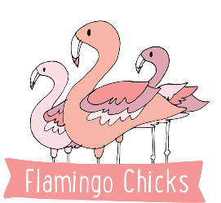**Teacher Application Form**

We are happy to support applications in a format that suits you – we are keen to make our teacher recruitment process as accessible as possible. If you would like to submit your application verbally, answers can be recorded in an audio or video file. Please do contact [jayne@flamingochicks.org.uk](mailto:jayne@flamingochicks.org.uk) if you require any support completing your application or to return completed submissions.

Please attach your CV alongside this application form.

|  |  |
| --- | --- |
| Given Name(s) |  |
| Surname |  |
| Preferred Pronouns |  |
| Address |  |
| Email |  |
| Tel: |  |
| Do you hold a clean enhanced DBS? | Yes / No |
| Driving license and car? | Yes / No |
| Do you hold a valid safeguarding certificate? | Yes / No |
| Do you hold a valid first aid certificate? | Yes / No |
| Please list your current availability for classes |  |

**Personal Statement**

We’d love to know a bit more about you. Please provide us with a personal statement that highlights your ability to deliver inclusive dance sessions and any experience of working with special educational needs, health conditions or disabilities (in reference to the job description and person specification).