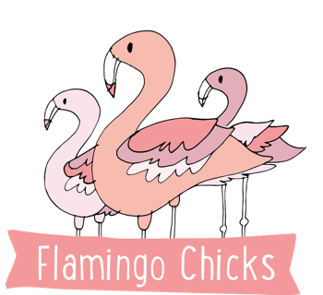

Flamingo Chicks’ Equality and Diversity Policy

Aims
Flamingo Chicks is open to all. We aim to foster an atmosphere of friendship, respect and care for each other. In particular, we aim to treat everyone equally, regardless of their age, disability, gender marriage or civil partnership, pregnancy or maternity, race, religion or belief, sex, or sexual orientation.

Inclusion and respect
Everyone at Flamingo Chicks should be made to feel equally welcome and included.
Sexist, racist, homophobic, transphobic or otherwise offensive and inflammatory remarks and behaviour are not acceptable. These constitute harassment, and have no place at Flamingo Chicks.
Equal opportunities in employment
Flamingo Chicks will avoid unlawful discrimination in all aspects of employment, including recruitment, promotion, opportunities for training, pay and benefits, discipline and selection for redundancy.

Recruitment
Person and job specifications will be limited to those requirements that are necessary for the effective performance of the job. Candidates for employment or promotion will be assessed objectively against the requirements for the job, taking account of any reasonable adjustments that may be required for candidates with a disability. Disability and personal or home commitments will not form the basis of employment decisions, except where necessary.
Working practices
Flamingo Chicks will consider any possible indirectly discriminatory effect of its standard working practices, including the number of hours to be worked, the times at which these are to be worked and the place at which work is to be done, when considering requests for variations to these standard working practices and will refuse such requests only if Flamingo Chicks considers it has good reasons, unrelated to any protected characteristic, for doing so. Flamingo Chicks will comply with its obligations in relation to statutory requests for contract variations. Flamingo Chicks will also make reasonable adjustments to its standard working practices to overcome barriers for disabled people.

Dealing with discrimination and harassment
If any person feels they have been discriminated against by Flamingo Chicks they should raise this with Claire Bridges, Chair of Trustees: clairecraig31@yahoo.com
The Flamingo Chicks Trustees will investigate the complaint, listening to all members involved. (If the complaint is against a Trustee, they will not be part of conducting the investigation).
If the complaint is against a particular individual, this person will have the opportunity to express their point of view, accompanied by a friend. The person making the complaint will also have this opportunity.
If the complaint is against Flamingo Chicks as a whole, the Trustees must work to ensure that such discrimination is not repeated in the future.
Any decision to exclude a person from the organisation due to discriminatory or harassing behaviour will be made with reference to Flamingo Chicks’ constitution. Flamingo Chicks will support people who feel they have been harassed or discriminated against and will not victimise or treat them less well because they have raised this.

Last Reviewed | October 2025
Next Review Date | October 2026
Author | Katie Sparkes, CEO and Founder

